|  |  |
| --- | --- |
|  | SharePoint Essentials Toolkit 2019 – What’s New? |
|  |  |
|  | 2018 vs 2019 Edition  11/27/18 |

SharePoint Essentials Toolkit

2018 vs 2019 Edition

Thank you for your interest in the SharePoint Essentials Toolkit 2019 Edition!

This release comes with support for SharePoint 2019 on-premises, as well as many new features and enhancements over the previous release. In this document we will cover some of the highlights in the SharePoint Essentials Toolkit 2019 Edition.

Improvements | Topics

Easier Navigation 3

SharePoint | Home Page Dashboard (default page) 3

Sites | Site and List Auditing 4

Security | Permissions Manager 5

Links | Broken Link Manager 6

Content | Content Management 7

Reports 8

Improved UI (User Interface) 9

Better Performance 9

Live Dashboard 9

Product Security Improvements 10

Office 365 Improvements 10

Fetching data 10

Back-Off Logic and Network Traffic Decoration 10

External Users and Guests 10

Sharing Links 11

Azure Active Directory Support 11

SharePoint 2019 Support 11

User Activity Reports 11

Item Query | Content Reports 12

Access Requests Report 13

More Fixes 14

Let us know what you think 14

# Easier Navigation

We listened to your feedback and added home pages for each component. Now when the user clicks a top navigation button, the corresponding page will appear (see below pages)

## SharePoint | Home Page Dashboard (default page)

The Home Page now shows an introduction page with a big button 😊 to add your sites. After a site is added, the Home Page Dashboard will change to show the sites and details for them.

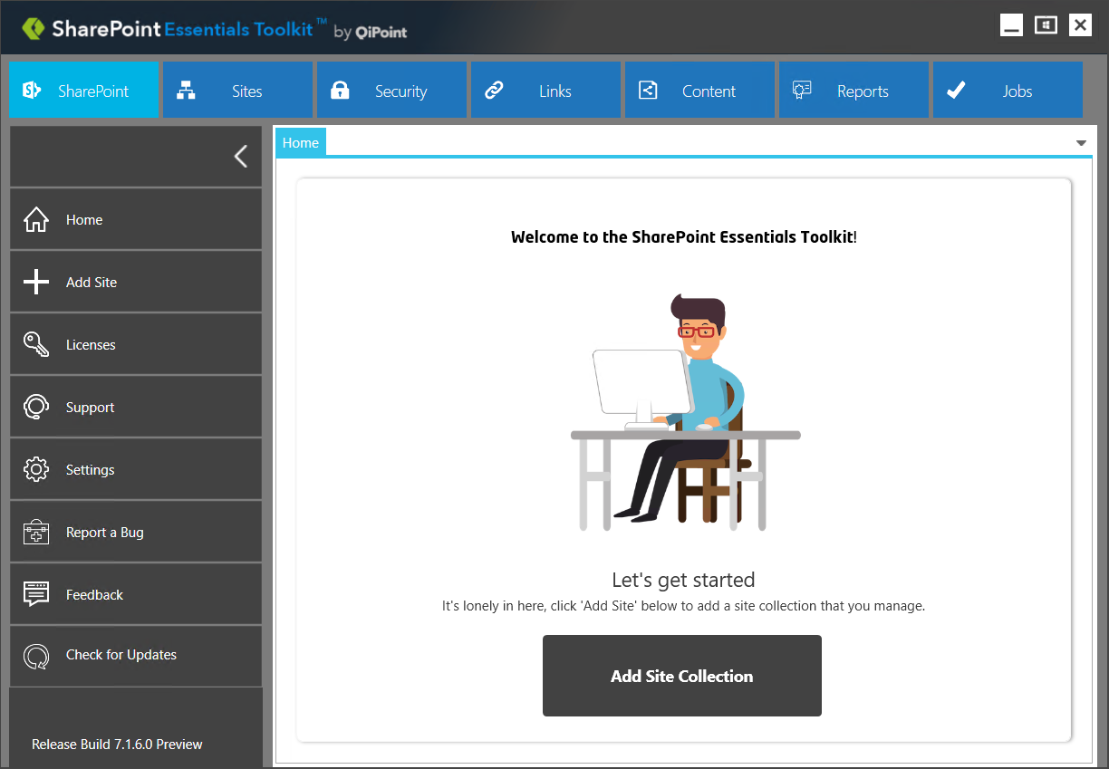

## Sites | Site and List Auditing

Site and List Auditing component now has ‘canned’ reports accessible directly from this page below. This page appears once a user clicks the ‘Sites’ button on the top navigation.

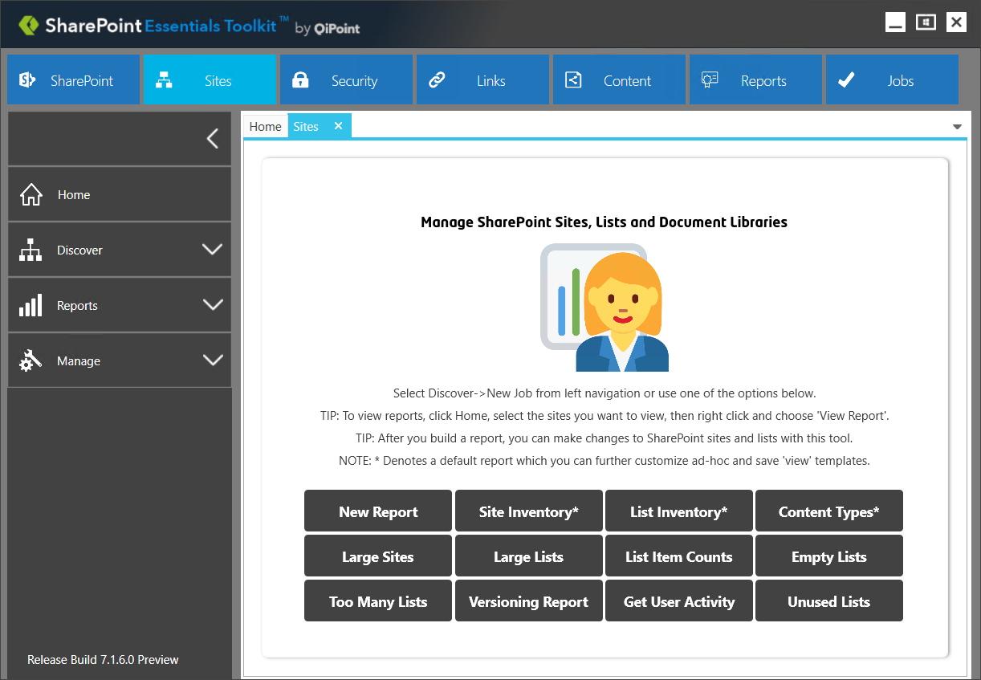

## Security | Permissions Manager

The Security section now has some of the more popular permission related reports you can generate with the tool. You can still create ad-hoc customized reports by clicking ‘New Report’.

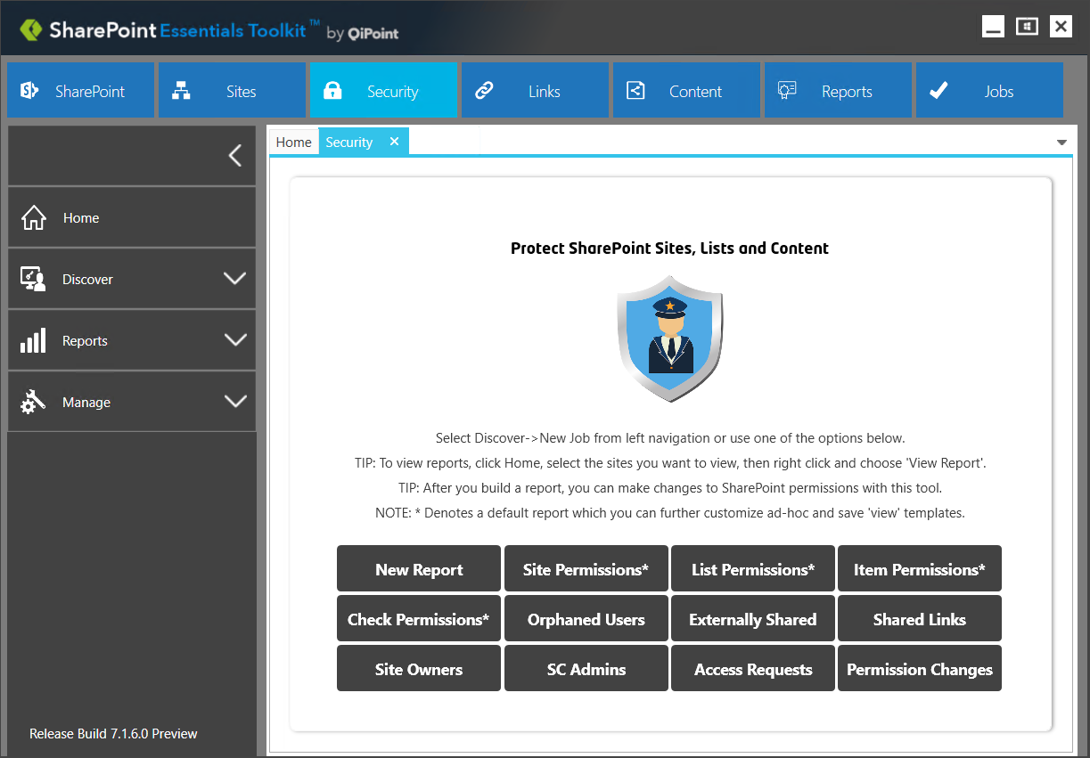

## Links | Broken Link Manager

Broken Link Manager has buttons in the page to quickly build the related ‘common’ reports below. You can still create ad-hoc customized reports by clicking ‘New Report’.

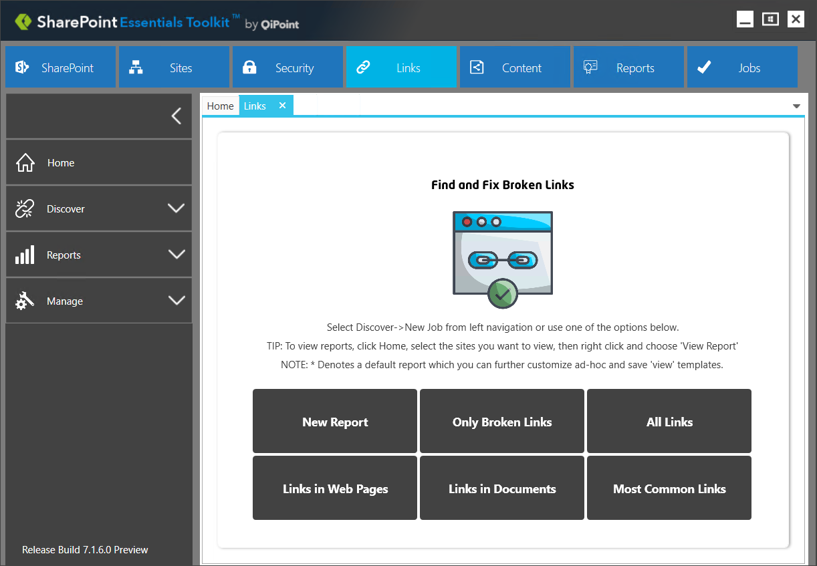

## Content | Content Management

Managing content in SharePoint is not always straightforward. We added this page to provide some popular reports that the SharePoint Essentials Toolkit can generate.

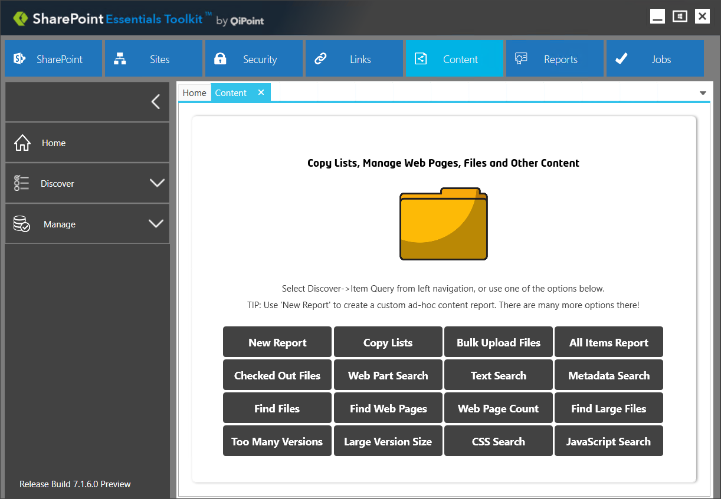

## Reports

Report Designer is in BETA but it will be released officially mid-2019. This section will be home for building, scheduling and exporting reports and policies for all the different components. Report Example: Site Collection report with visual and detailed summaries of all sites, lists, broken links, large files, active users, etc... in one.

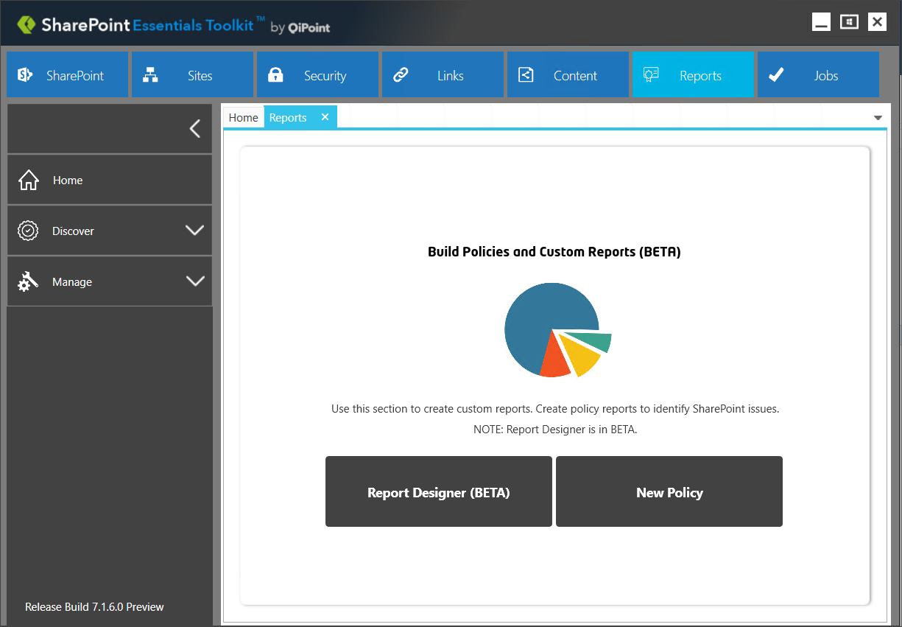

# Improved UI (User Interface)

We tightened up and updated all controls, such as textboxes, buttons, navigation and layout to improve working areas for laptops and lower resolution displays. We kept the overall look and feel the same to reduce chances of a steep learning curve for users.

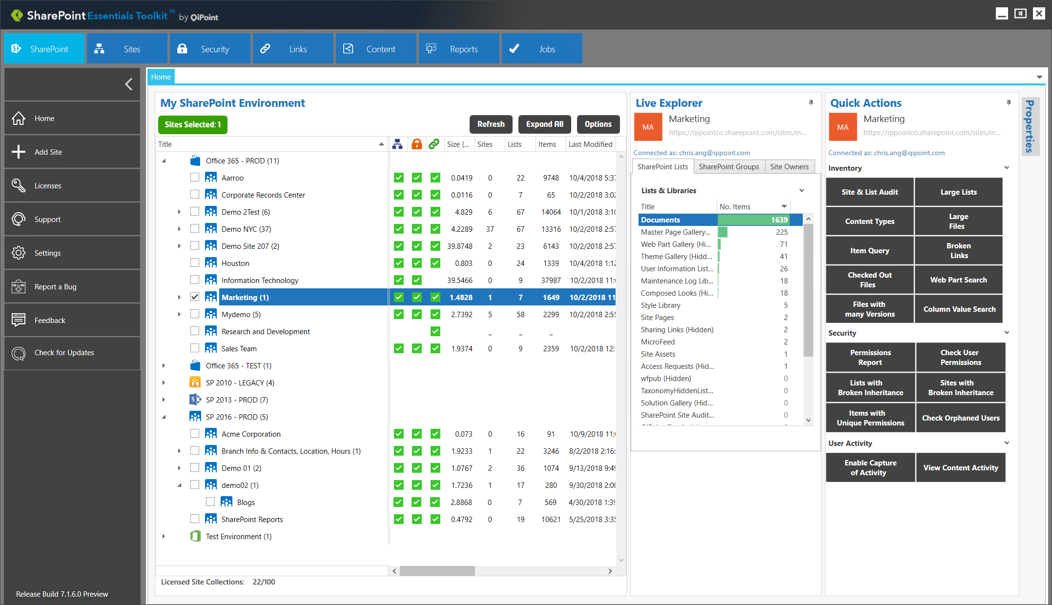

# Better Performance

We have made improvements to the Home Page Dashboard menu (to load more quickly) as well performance improvements for report generation.

# Live Dashboard

We updated the Live Explorer Panel to load more efficiently.

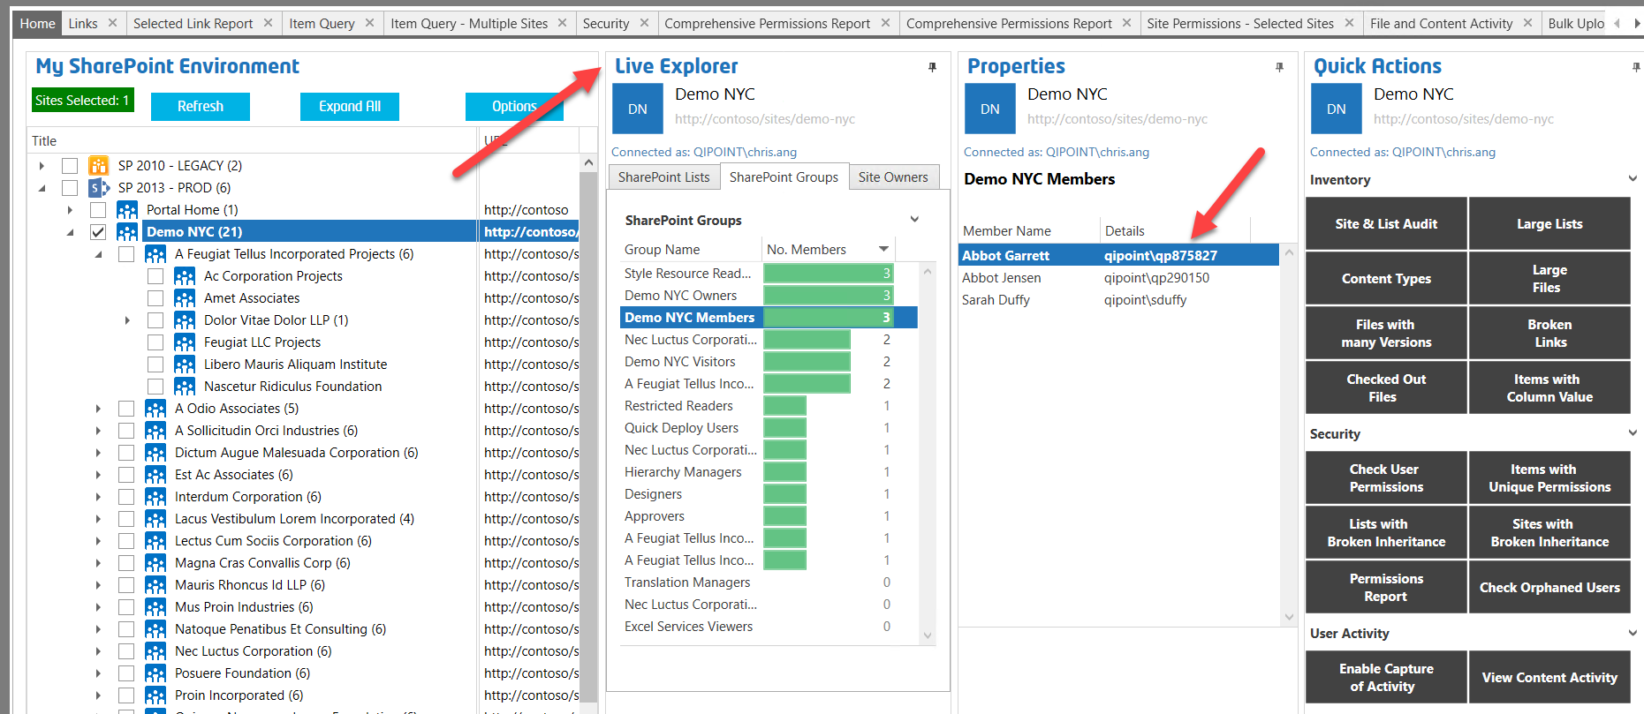

# Product Security Improvements

There have been product wide security and encryption improvements for storing data and passwords (now uses AES 256Bit length for all passwords stored in connection files). This was updated in SharePoint 2018 release in Q4.

# Office 365 Improvements

## Fetching data

We improved how we fetch data from Office 365 to retrieve content more efficiently in this release. This contributed to performance improvements.

## Back-Off Logic and Network Traffic Decoration

We have added ‘Back-off’ logic (2018 Edition Q2) to prevent Microsoft Office 365 throttling which decorates the network traffic with our product information as well as ‘sequences’ requests as needed for customers who are performing intensive migration jobs in parallel with generating reports.

## External Users and Guests

Reports now include information to help you easily identify sites that have externally shared content, as well as list the external users and guests who have access to the site content.

## Sharing Links

Reports include a list of all Sharing links. AS well as a new facility to remove Sharing links (and the members who have access through the sharing link) in bulk with the tool.

# Azure Active Directory Support

Permission reports can now natively connect to and report on Azure AD group members. This includes both Office 365 Groups and Azure AD Security Groups inside of Azure AD.

Consent needs to be granted once to the application at <https://www.cognillo.com/sharepoint-essentials-toolkit-consent> and users can build reports which include AD Group Members (nested permissions) with:

**Read + Enumerate Permissions (Permission Level)**

NOTE: The tool does not require users to be Site Collection Admins or have Full Control to run permission reports.

The SharePoint Essentials Toolkit now uses the Microsoft recommended “MS Graph API” (not Azure AD Graph) to connect to Azure Active Directory to query information, such as Azure AD Group members.

# SharePoint 2019 Support

This edition brings official support for SharePoint 2019.

# User Activity Reports

Improvements to the User Activity reports (which sit on top of the SharePoint Site Collection Auditing feature). We updated the description of events in User Activity Content Reports, to show a friendlier description of what was viewed, changed, or deleted content, modified permissions within the selected SharePoint sites.

# Item Query | Content Reports

We have made even more improvements to the Item Query component. The Item Query feature now has even more options when reporting on content within SharePoint. For example, we added new groupings and menu options for find all web parts in web pages across selected SharePoint sites; find content with profanity; credit card numbers or sensitive information that need to be classified or flagged; get a list of all web pages across selected sites, get a report on all checked out files or files with no checked in state, plus many more.

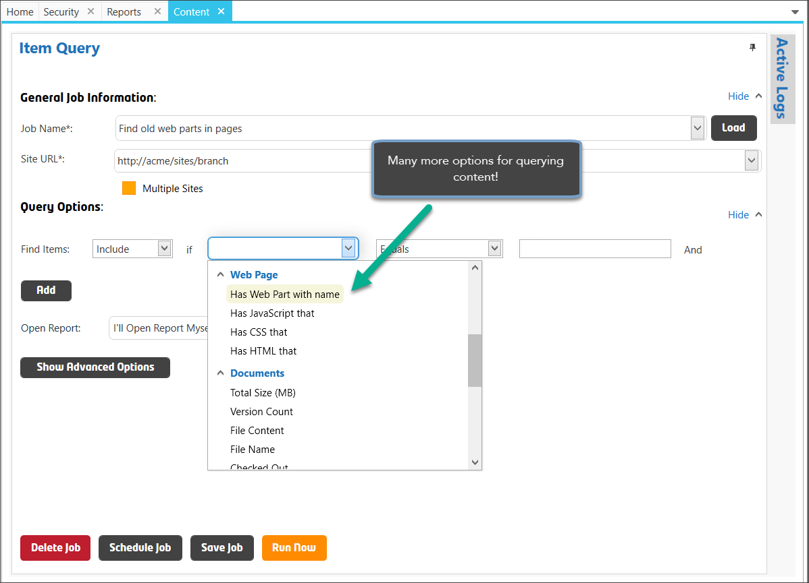

# Access Requests Report

(SharePoint 2016, 2019 and SPO) We added a new report to Permissions Manager (Security section) called ‘Access Requests Report’. This report allows you to view all requests for access to sites and the approval status and date & time of the requests.

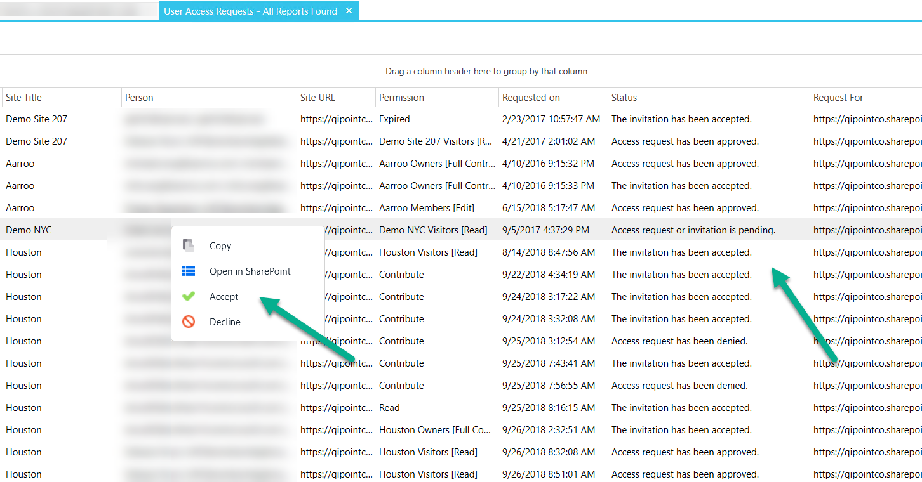

# More Fixes

We are always looking to improve this product. As we add new features and resolve bugs and issues, we add them to our releases. There are many fixes included and rolled into this latest release.

# Let us know what you think

Please give us [feedback](https://www.getfeedback.com/r/cIgfCzp1), so we can provide content that’s truly useful and helpful. Thanks!